
Amazon Interview Worksheet
THINK BIG
Definition and Indicators
Think Big: Thinking small is a self-fulfilling prophecy. Leaders create and communicate a bold direction that inspires results. They think differently and look around corners for ways to serve customers.
What this looks like in Practice
As a people manager do you… | As an individual contributor do you…
- Take a radical approach and risks when necessary, always questioning traditional assumptions in pursuit of the biggest and best idea?
- Create a gutsy mission that employees can be inspired by and get behind; provide direction for how to get there and explain how everything fits into the long-term plan?  - Continually communicate the big picture and mission to the team in a manner that gets employees excited (as a result, employees want to get out of bed and come to work each day)?  - Actively explore new ideas from team members, encouraging risk taking when appropriate? | - Translate broader mission into big, hairy ideas and tactics in your own work?  - Ask questions to get a sense of direction and confirm how work fits into the short- and long-term picture?  - Hungrily accept the challenge to create the best idea/solution and take risks?

Think Big - Suggested Behavioral Interview Questions
For each question you choose, use a separate STAR Worksheet
Questions for (Manager) in parentheses

- Give me an example of a radical approach you proposed to solve a big problem. What was the problem and why did you feel it required a completely different way of thinking about it? Was your approach successful?
- How do you drive adoption for your vision/ideas? How do you know how well your idea or vision has been adopted by other teams or partners? Give a specific example highlighting one of your ideas.
- Tell me about time you were working on an initiative or goal and saw an opportunity to do something much bigger than the initial focus.
- Tell me about a time you looked at a key process that was working well and questioned whether it was still the right one? What assumptions were you questioning and why? Did you end up making a change to the process?
- Tell me about a time you took a big risk – what was the risk, how did you decide to do it and what was the outcome?
- Now Tell me about a time you took a big risk and it failed. What did you learn? What would you do differently?
- Tell me about a time you came up with the vision for a (team, product, strategic initiative) when there wasn’t a guiding vision. What was it? How did you gain buy-in and drive execution? (Manager)
- Tell me about encouraging or enabling a member of your team to take big risk. How did you balance the risk to the business with possible positive outcome for the organization and opportunity for learning for your direct report? (Manager)
- Tell me about time you had to develop a product/business model from scratch or when you dramatically changed one in a turnaround situation. (Manager)
STAR WORKSHEET

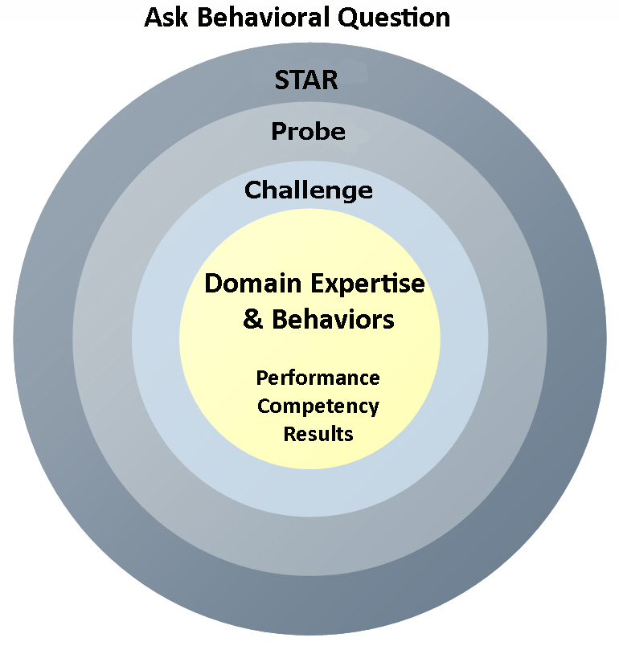
Your Behavioral Question:___________________________________________________________________Leadership Principle:_________________

- Choose behavioral question that provoke specific examples or stories for your assigned Leadership Principle(s).
- Process the example using STAR. Stories have beginnings (Situation/Task), middles (Actions) and ends (Results).
- Once you have established the story, PROBE to dive deeper on your assigned competency (Leadership Principle), get clarity or pursue a concern.
- If appropriate, CHALLENGE the candidate’s statements, decisions or thought process.
S  T | SITUATION/TASK - Describe the situation/task you faced and the context of the story  Answers the questions: where did this occur, when did it happen, why is it important?  Probing Questions:  - Why is this important? What was the goal?  - What was the initial scope of the project? What were the challenges?  - What were the risks and potential consequences if nothing happened?  Challenge Questions:  - Why did you choose this story to illustrate a xyz accomplishment?  - What other stories can you think of that demonstrate.. xyz?  - Could you come up with an example that is more recent? | Notes  - Give me an example of a radical approach to a problem you proposed. What was the problem and why did you feel it required a completely different way of thinking about it? Was your approach successful?  - How do you drive adoption for your vision/ideas? How do you know how well your idea or vision has been adopted by other teams or partners? Give a specific example highlighting one of your ideas.  - Tell me about encouraging or enabling a member of your team to take big risk. How did you balance the risk to the business with possible positive outcome for the organization and opportunity for learning for your direct report? (Manager)
A | ACTION - What actions did you take?  Answers the questions: what did you personally own, how did you do it, who else was involved?  Probing Questions:  - Deep probe functional expertise and/or assigned core competency.  - Were you the key driver or project owner?  - What was your biggest contribution? What unique value did you bring?  - What were the most significant obstacles you faced? How did you overcome them?  Challenge Questions:  - What did you do specifically versus the team?  - How did you set priorities…deal with xyz problem… or get manager buy-in?  - What decisions did you challenge? Why? How did you influence the right outcome?
R | RESULTS - How did you measure success for this project? What results did you achieve?  $ Cost savings, revenue generation  # Quantify to understand volume, size, scale  % Percentage change, year over year improvements  Time to market, implementation time, time savings  Impact on the customer, the team  δ Quality improvements  Probing Questions:  - Why did you choose to focus on these results? What other results were important?  - You mentioned revenue, what percentage change is that year over year?  - What trade-offs did you have to make to achieve this? (quality, cost, time)  - I’m concerned about… (the time it took, the volume, the customer impact), tell me more…  Challenge Questions:  - What were the lessons learned? What would you have done differently?  - How would you implement this at Amazon?  - How did these results compare to your actual goals? (refer back to goal stated in Situation)

